Vorstellung 01

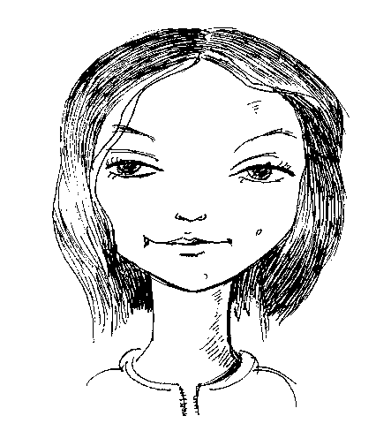

Vorstellung 03

Vorstellung 02

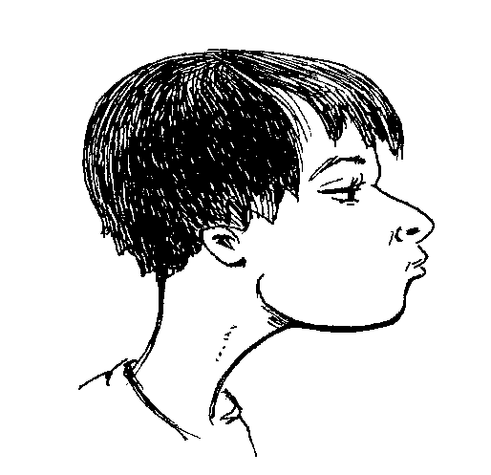 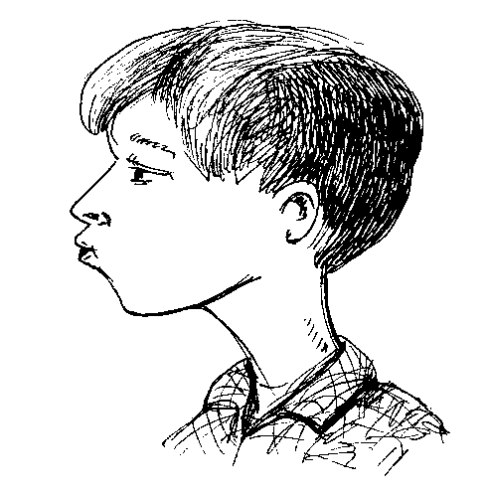

Vorstellung04

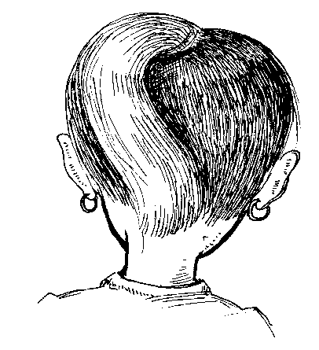

Was denkst du ?

____________________________________________________________________________

Vorstellung 01

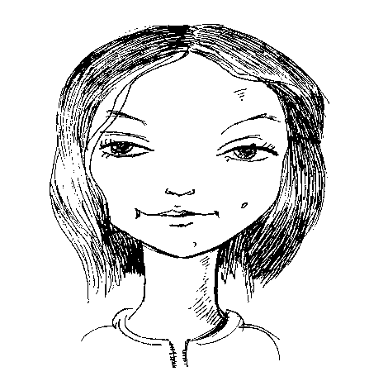

Vorstellung 03

Vorstellung 02

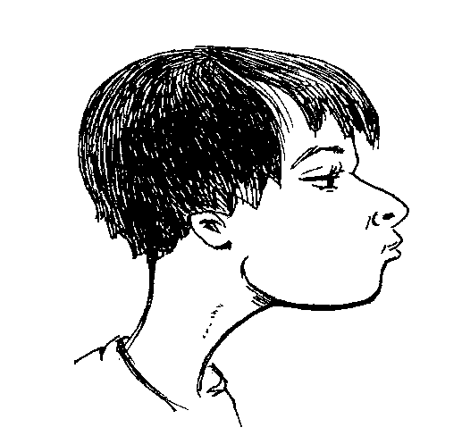 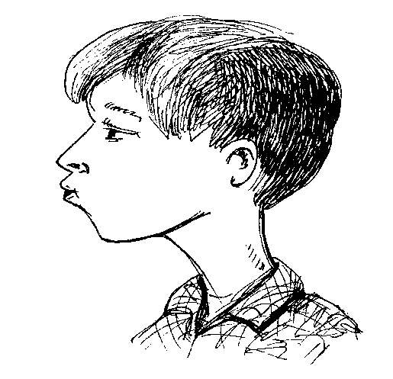

Vorstellung 04

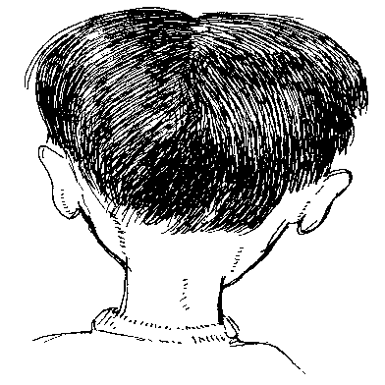

Wasdenkst du ?

____________________________________________________________________________

Vorstellung 01

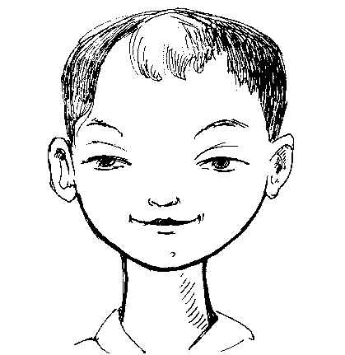

Vorstellung 02

Vorstellung 03

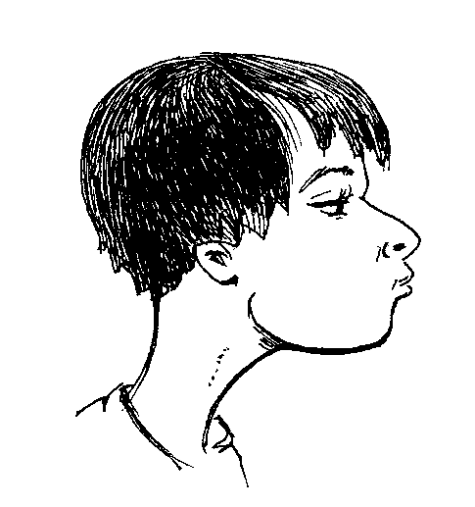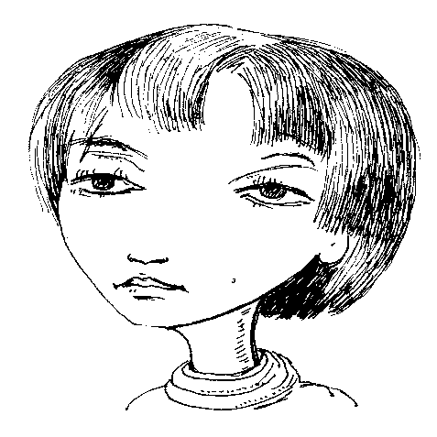

Vorstellung 04

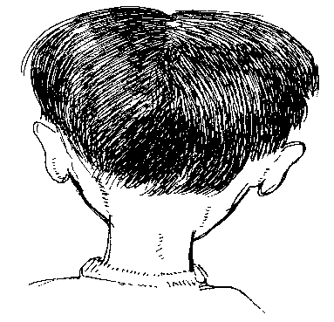

Was denkst du ?

# *Quelle: HANS-DIETER BARKE*

H.-D. Barke, Professor of Chemisty and Chemistry Education, Director of the Institute of Chemical Education at University of Muenster, conducts research and teaches chemical education for chemistry would be teachers. After PhD and Habilitation at University of Hannover (Germany), he got the Johann-Friedrich-Gmelin award of the Society of German Chemists in 1986. He did a sabbatical at San Diego State University/USA in 1986/87, took a professorship at Uni-versity of Jena and since 1996 he is a professor at University of Muenster. With Prof. Dr. Guenther Harsch he wrote a textbook on chemical education (Chemiedidaktik Heute, Heidelberg 2001, Springer). He did empirical research according to chemistry misconceptions and wrote a book on diagnosis, prevention and cure of misconceptions (Heidelberg 2006, Springer). He presented important results of his research on international congresses such as ECRICE (2006, Budapest in Hungary), BCCE (2006, Purdue University, Indiana, USA), ChemEd (2007, Denton, Texas, USA) or ICCE (2008, Mauritius); and by invitation at Addis Ababa University (Ethiopia), Herzen Pedagogical University of St. Petersburg (Russia), Riga Technical University (Latvia), University of Sydney (Australia), and Weizmann Institute (Israel).

Hans- Dieter Barke is a professor and head of the chemistry education institute at the University of Muenster (WWU), Germany.

* He has M.Sc. and Ph.D. in chemistry education and extensive teaching experience for more than three decades. He served at universities of Venia, Hanover, Jena and one year teaching at the Chemistry Department San Diego State University in California, USA.
* His research interests are chemistry misconceptions, spatial ability…………………….
* He is award winner of Johann Friedrich Gmelin of the Society of German Chemists, in 1986.
* He published more than 115 papers related to chemistry education.
* He is the Author of “Chemie didaktiks: Diagnose und Korrekture von Schülervorstellungen”;and co-author of “Chemie Didaktik Heute: Lernprozesse in Theorie und Praxis”.
* He also developed a science kit for developing countries: Ethiopia and Tanzania.

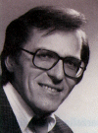

# *Temechegn Engida*

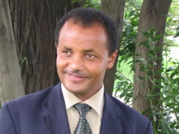

Temechegn Engida is the President of the Federation of African Societies of Chemistry (FASC), based in Addis Ababa, Ethiopia. He is also a member of the International Advisory Board of the 42nd IUPAC Congress that will be held in August 2009. He got his B.Sc. in Chemistry and M.A. in Curriculum and Instruction (with emphasis on Chemical Education) from the Addis Ababa University, and a PhD in Chemistry Didactics from the University of Muenster, Germany. He has taught in the Addis Ababa University for many years, published articles on chemistry education and wrote teaching materials on such subjects as Brain Compatible Chemistry, Models and Methods of Teaching Chemistry, Computer Applications and Technology in Chemistry Teaching, etc. Currently he works for the UNESCO International Institute for Capacity Building in Africa (IICBA).

# *SILESHI YITBAREK*

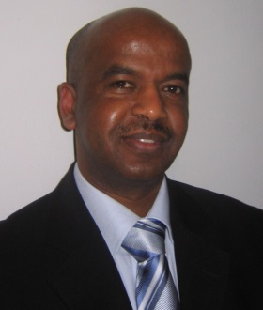

Sileshi Yitbarek had his B.SC in Chemistry and MA in Curriculum and Instruction at the Addis Ababa University. He is a lecturer at Kotebe College of Teacher Education in Ethiopia and has also served as a tutor in the professional development of higher education lecturers on Methods of Active Learning. He published modular course materials for Analytical Chemistry, Applied Chemistry, and Teaching-Learning Methods of chemistry. He is also a co-author of “Concept-Cartoons - as a strategy in teaching, learning and assessment chemistry”. Presently, with a scholarship of DAAD (German Acedemic Exchange Service) he is a doctoral candidate in Chemistry Education at the University of Muenster in Germany.